***Hyphenated Adjectives***

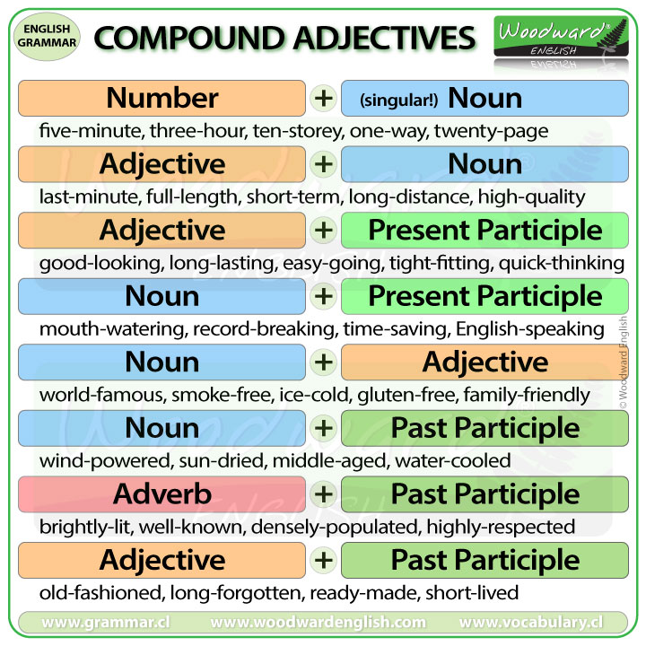

**Contents**

Number + noun 1

Adjective + noun 2

Adjective + Present Participle 2

Noun + present participle 3

Noun + adjective 3

Noun + past participle 4

Adverb + past participle 4

# **Number + noun**

These adjectives provide specificitay and precision in describing quantity or size. For example, "three-year-old," "five-star," or "ten-mile" convey a clear and concise description, enhancing communication efficiency.

1. Five-star
2. Two-hour
3. Three-story
4. Ten-year-old
5. Six-foot-tall
6. Three-steps
7. Four-legged
8. Two-headed
9. One-way
10. Two-way

# **Adjective + noun**

These adjectives provide additional information about a noun, often specifying a particular quality, characteristic, or attribute. For example, "high-quality," "bright-colored," or "heavy-duty" convey specific details about the noun they modify, enhancing precision in communication.

1. High-pitched
2. Soft-spoken
3. Cold-hearted
4. Bright-colored
5. Heavy-duty
6. Sharp-tongued
7. Deep-seated
8. Narrow-minded
9. Open-ended
10. Full-bodied
11. Red-handed
12. Short-tempered
13. Fast-paced
14. Cold-blooded
15. Broad-minded
16. Dull-painted

# **Adjective + Present Participle**

These adjectives convey a dynamic quality or an ongoing characteristic, providing a nuanced description of a noun. Examples include "fast-moving," "slow-cooking," or "bright-shining," adding depth to the description.

1. Fast-moving
2. Slow-cooking
3. Cold-calling
4. Hard-hitting
5. High-pitched
6. Deep-frying
7. Smooth-talking
8. Quick-thinking
9. Tight-fitting
10. Clear-cutting

# **Noun + present continous**

These adjectives convey ongoing actions or characteristics associated with the noun, offering a dynamic and specific description. Examples include "mind-boggling," "heartwarming," or "eye-opening."

1. Mind-boggling
2. Heartwarming
3. Eye-opening
4. Hair-raising
5. Jaw-dropping
6. Breath-taking
7. Time-consuming
8. Soul-searching
9. Blood-curdling
10. Thought-provoking

# **Noun + adjective**

These adjectives enhance specificity, providing a more detailed and nuanced description of the noun. Examples include "time-consuming," "energy-efficient," or "health-conscious," conveying precise characteristics and qualities associated with the noun.

1. Time-consuming
2. Energy-efficient
3. Health-conscious
4. Labor-intensive
5. Cost-effective
6. User-friendly
7. Environmentally-friendly
8. Water-resistant
9. Culture-specific
10. Data-driven

Top of Form

# **Noun + past participle**

These adjectives convey a characteristic or quality resulting from a past action or condition associated with the noun. Examples include "goal-oriented," "weather-beaten," or "risk-assessed."

1. Goal-oriented
2. Weather-beaten
3. Risk-assessed
4. Time-tested
5. Adventure-filled
6. Fact-checked
7. Sun-drenched
8. Fun-filled
9. Duty-bound

# **Adverb + past participle**

These adjectives convey a quality or characteristic resulting from a past action or condition associated with the adverb. Examples include "well-known," "highly-regarded," or "carefully-crafted."

1. Well-known
2. Highly-regarded
3. Poorly-executed
4. Carefully-crafted
5. Swiftly-moving
6. Deeply-rooted
7. Brightly-lit
8. Openly-discussed
9. Badly-damaged
10. Softly-spoken

# **Adjective + past participle**

These adjectives convey a quality or state resulting from a past action or condition. They enhance precision and clarity in describing characteristics. Examples include "well-known," "high-pitched," or "deep-fried."

1. Well-known
2. High-pitched
3. Cold-hearted
4. Open-ended
5. Hard-earned
6. Deep-fried
7. Broken-hearted
8. Time-tested
9. Close-knit